REGISTRATION FORM
Civil War Reenactment,
Fort Trumbull New London, CT August 13th-14th, 2022
Name of Unit: ________________________________________________
Affiliation: New England ____ Liberty Greys _____ What Remains _____ Other _____ Unit
Contact Person: _____________________________________________
Address: ________________________________________________
City/Town: ________________________________ State: _______ ZIP Code: ____________
Telephone (____)________________ Email: ________________________________________
Commanding Officer: ____________________________________________
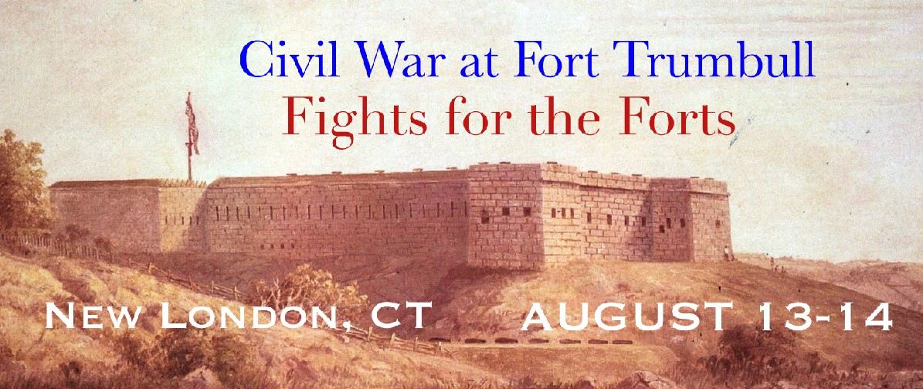
Soldiers #: ________ Civilians #: __________ Children #: _________(under 12 FREE: ______) Artillery Type: __________________________________________________________________
Additional Information:
- Set up on Friday August 12, after 3:00 P.M. to 10:00 P.M.
- Approved Artillery Units Only
REGISTRATION FEE: $10 per person (WALK ON FEE $15 per person)
REGISTRATION DEADLINE: August 5th, 2022
Please make checks payable to: 8th Regiment Conn Vol Inf Co A
Send to: Jacob Bates
118 Water Street
Stonington CT 06378 jacobbates1863@icloud.com
Affiliations: NEB, LG, USV

Unit Roster

- Rank: _______Name: _______________________________________________ Type: Soldier Civilian Child (FREE under 12)
Phone #: (___) ___________ Email: _____________________________________

- Rank: _______Name: _______________________________________________ Type: Soldier Civilian Child (FREE under 12)
Phone #: (___) ___________ Email: _____________________________________

- Rank: _______Name: _______________________________________________
*Type: Soldier Civilian Child (FREE under 12)
Phone #: (___) ___________ Email: _____________________________________

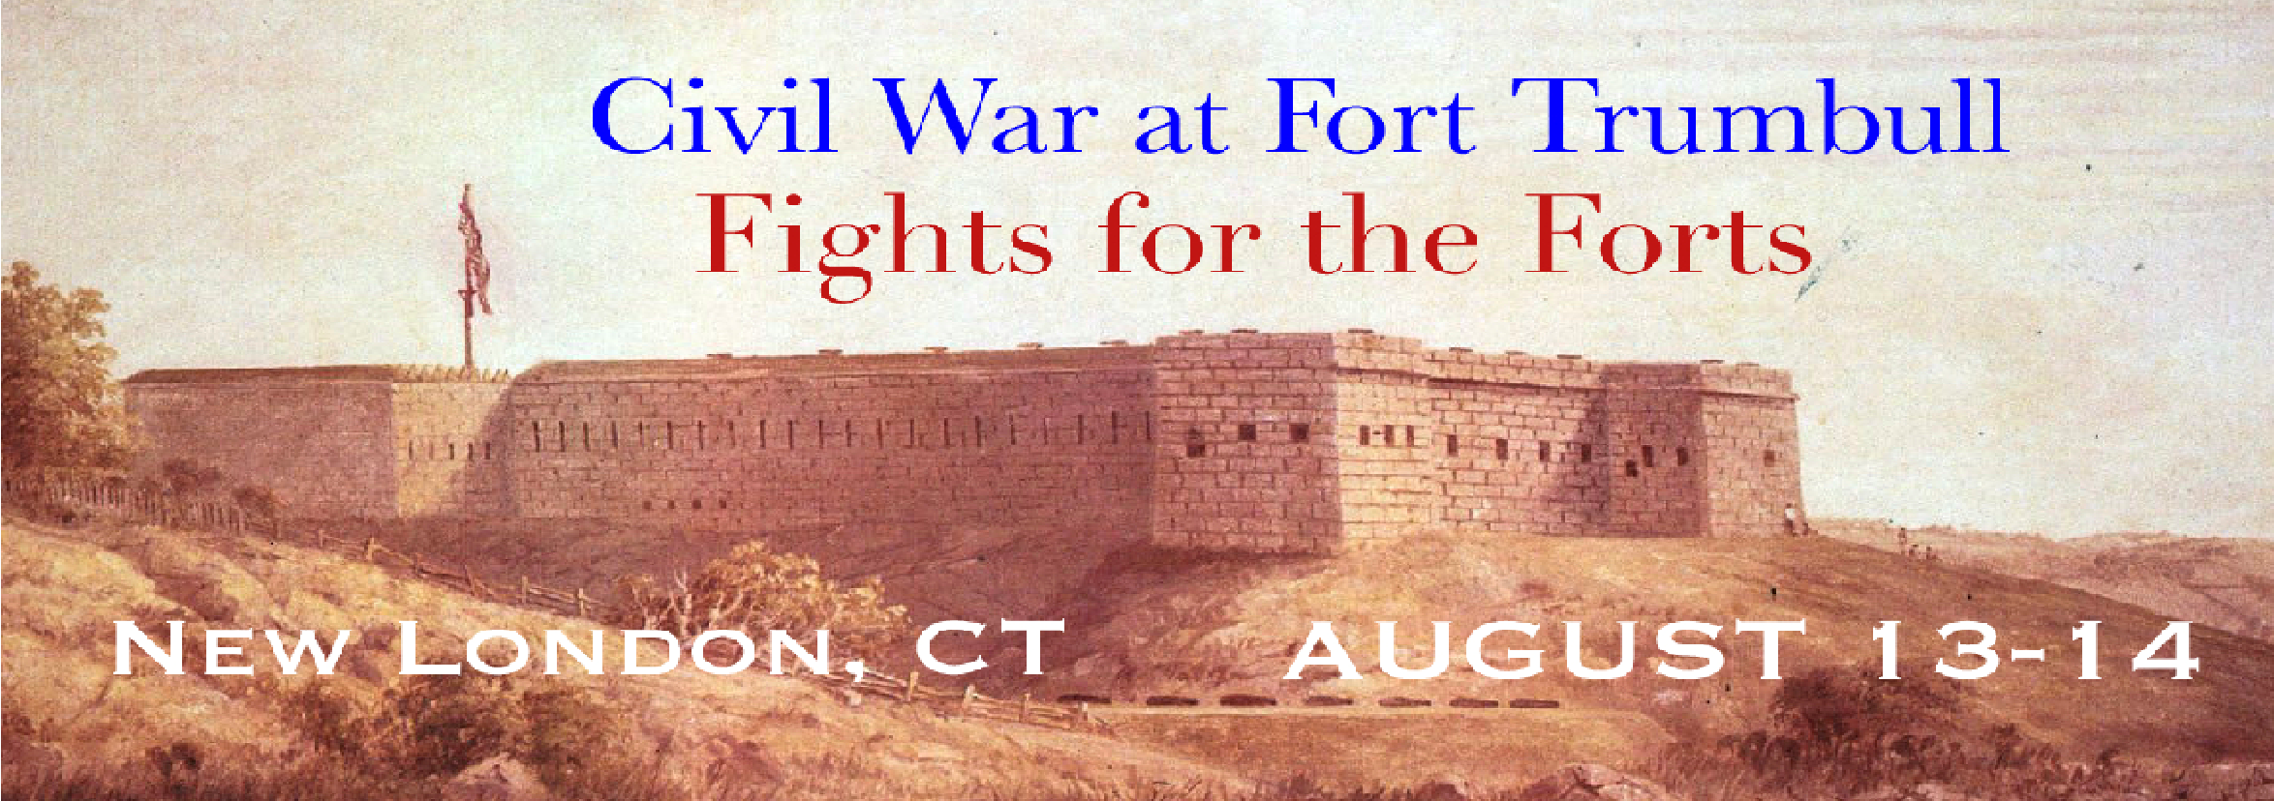
- Rank: _______Name: _______________________________________________
Type: Soldier Civilian Child (FREE under 12)
Phone #: (___) ___________ Email: _____________________________________
- Rank: _______Name: _______________________________________________ Type: Soldier Civilian Child (FREE under 12)
Phone #: (___) ___________ Email: ____________________________________

6. Rank: _______Name: _______________________________________________
Child (FREE under 12)
Type: Soldier Civilian
Phone #: (___) ___________ Email: _____________________________________

7. Rank: _______Name: _______________________________________________
Type: Soldier Civilian Child (FREE under 12)
Phone #: (___) ___________ Email: _____________________________________

8. Rank: _______Name: _______________________________________________
Type: Soldier Civilian Child (FREE under 12)
Phone #: (___) ___________ Email: _____________________________________

9. Rank: _______Name: _______________________________________________ Type: Soldier Civilian Child (FREE under 12)
Phone #: (___) ___________ Email: _____________________________________

10. Rank: _______Name: _______________________________________________ Type: Soldier Civilian Child (FREE under 12)
Phone #: (___) ___________ Email: _____________________________________

11. Rank: _______Name: _______________________________________________
Type: Soldier Civilian Child (FREE under 12)
Phone #: (___) ___________ Email: _____________________________________

12. Rank: _______Name: _______________________________________________
Type: Soldier Civilian Child (FREE under 12)
Phone #: (___) ___________ Email: _____________________________________

13. Rank: _______Name: _______________________________________________

Type: Soldier Civilian Child (FREE under 12)
Phone #: (___) ___________ Email: _____________________________________

14. Rank: _______ Name:______________________________________________
Type: Soldier Civilian Child (FREE under 12)
Phone #: (___) ___________ Email: _____________________________________
- Rank: _______*Name: _______________________________________________
Type: Soldier Civilian Child (FREE under 12)
Phone #: (___) ___________ Email: _____________________________________

- Rank: _______Name: _______________________________________________
Type: Soldier Civilian Child (FREE under 12)
Phone #: (___) ___________ Email: _____________________________________
- Rank: _______Name: _______________________________________________ Type: Soldier Civilian Child (FREE under 12)
Phone #: (___) ___________ Email: _____________________________________
- Rank: _______Name: _______________________________________________
Type: Soldier Civilian Child (FREE under 12)
Phone #: (___) ___________ Email: _____________________________________

- Rank: _______Name: _______________________________________________
Type: Soldier Civilian Child (FREE under 12)
Phone #: (___) ___________ Email: _____________________________________
- Rank: _______Name: _______________________________________________
Type: Soldier Civilian Child (FREE under 12)
Phone #: (___) ___________ Email: _____________________________________

